Day 10

Multi-threading

**Task 1**: What is a process?

When we are performing an action, a series of actions or things have to be done to get the desired result. This series of actions is called a Process.

Examples: examples include daily routines like preparing coffee or food, in an organization like onboarding an employee, training an employee etc.

**Task 2**: What is a Thread?

It is like a mini program running inside a large program. Threads are light weight. Threads are the smallest unit of process.

**Task 3**:

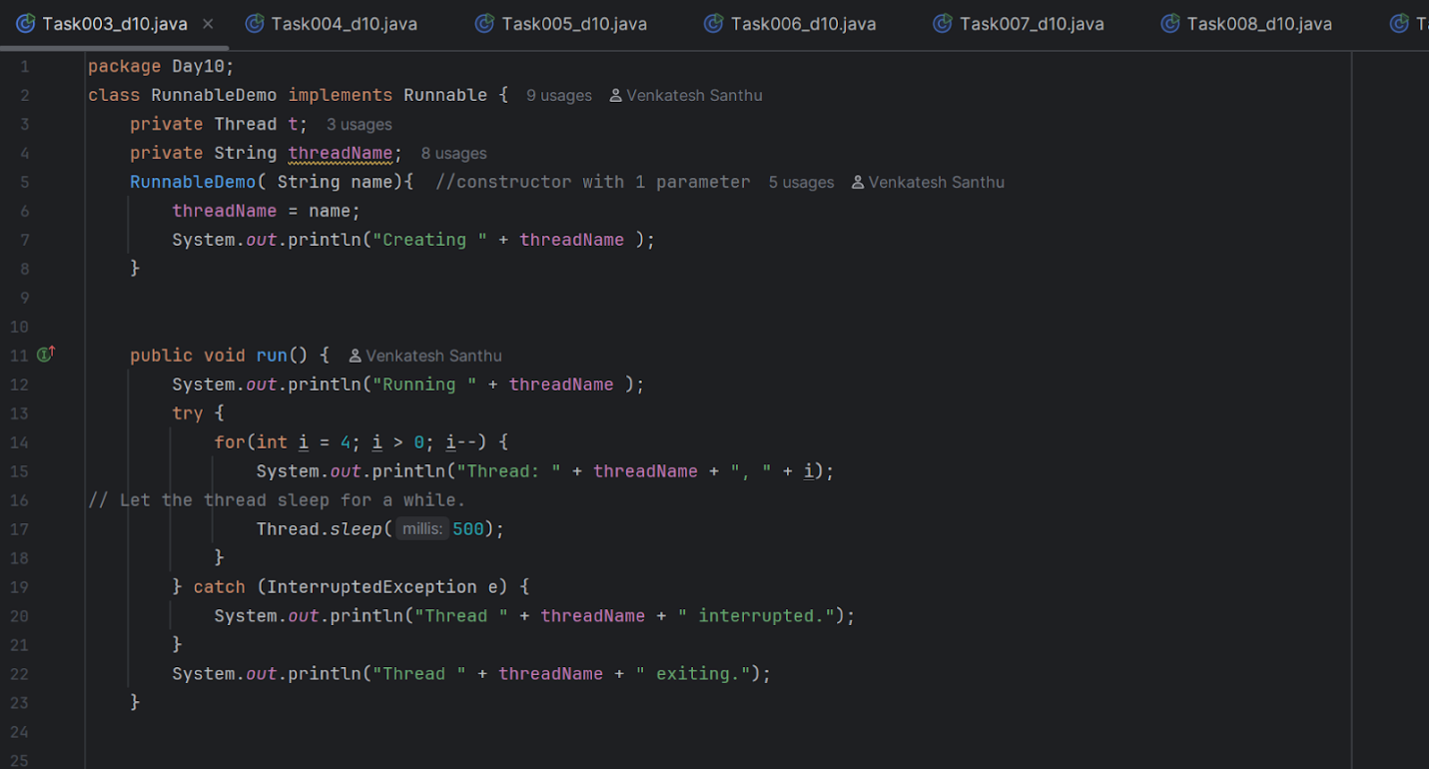

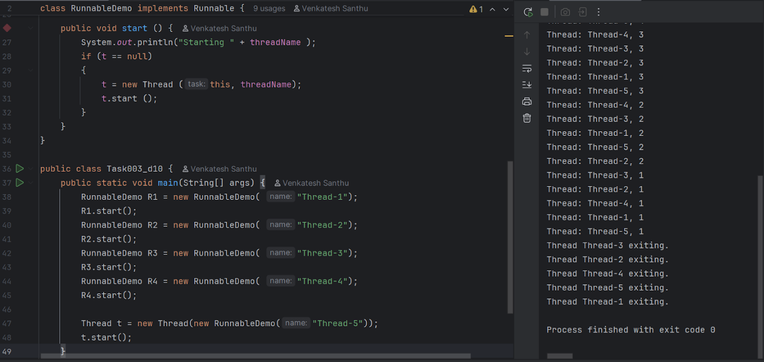

**Task 4**:

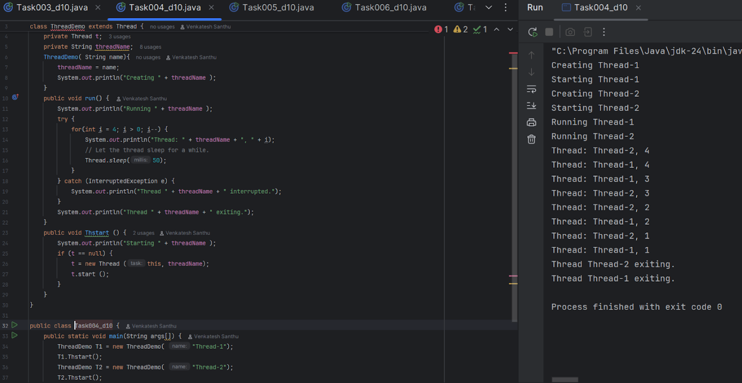

**Task 5**:

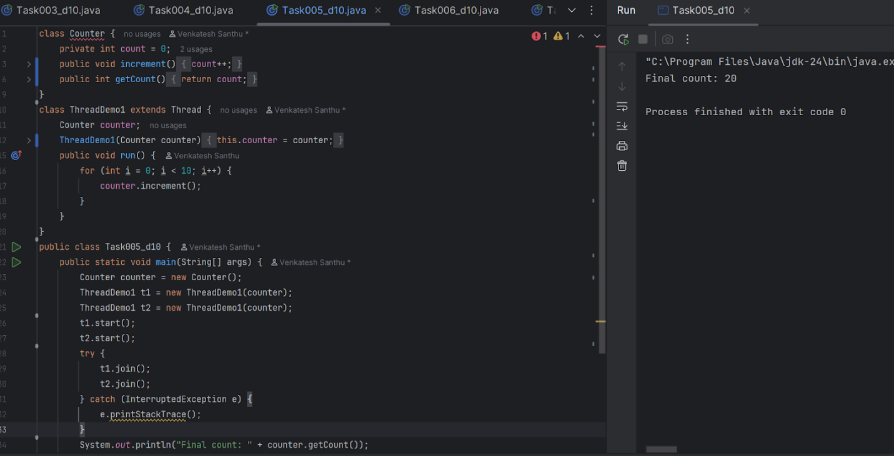

**Task 6**:

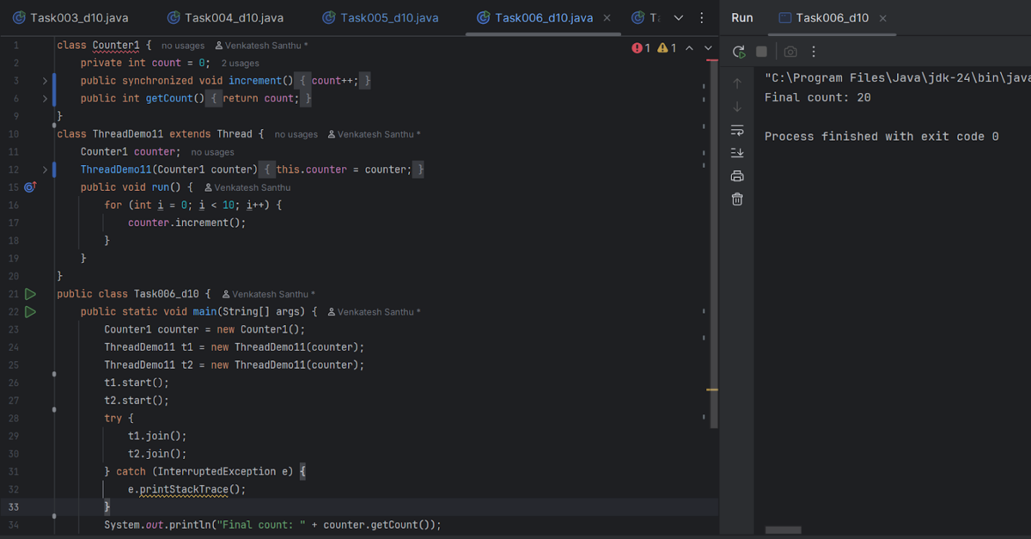

**Task 7**:

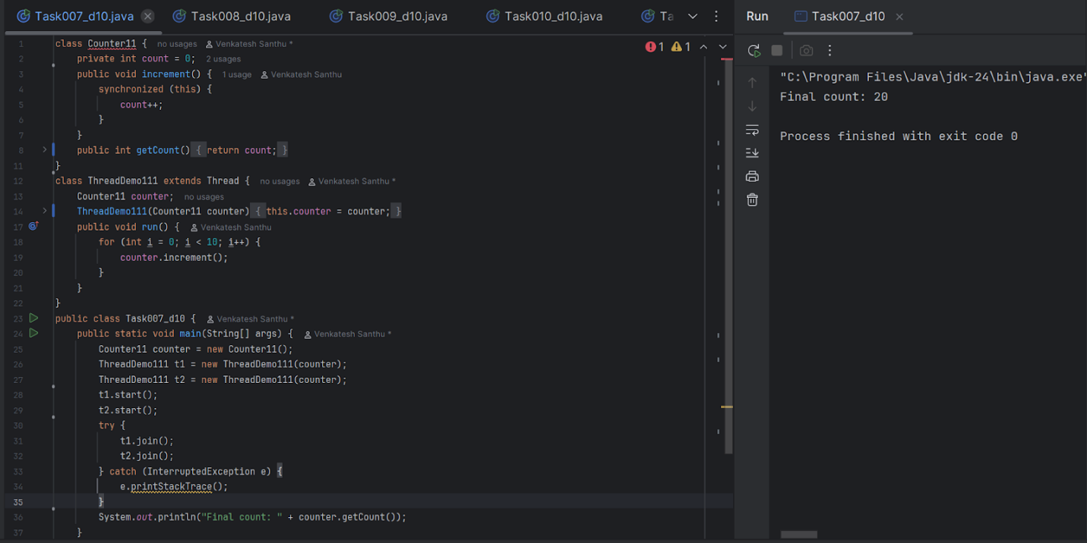

**Task 8**:

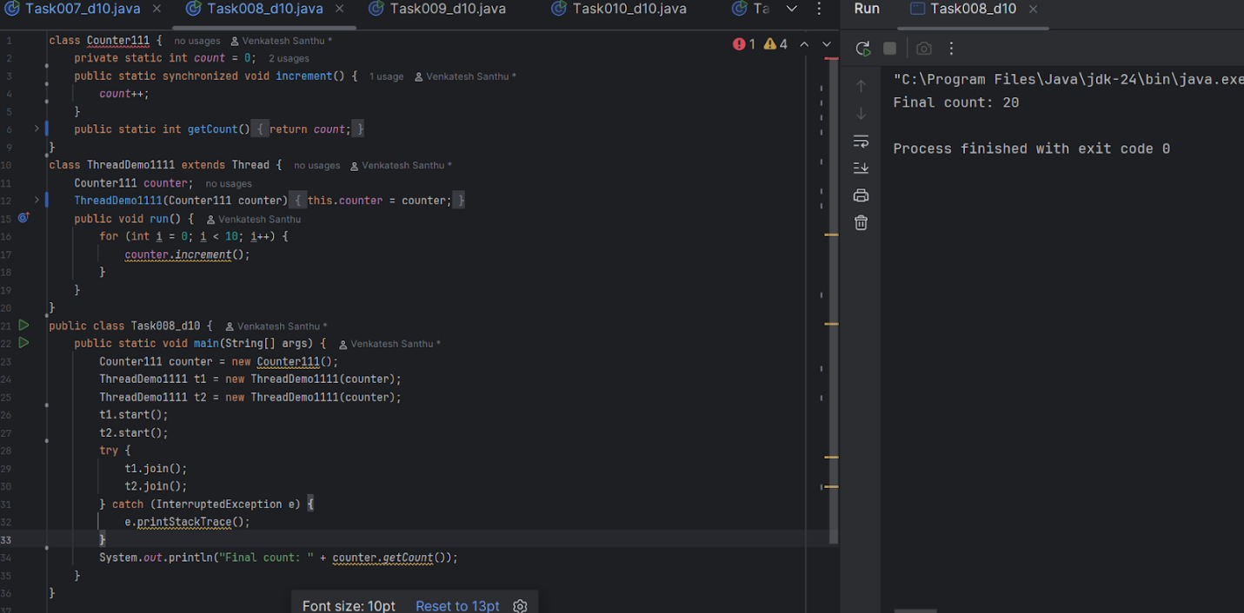

**Task 9**:

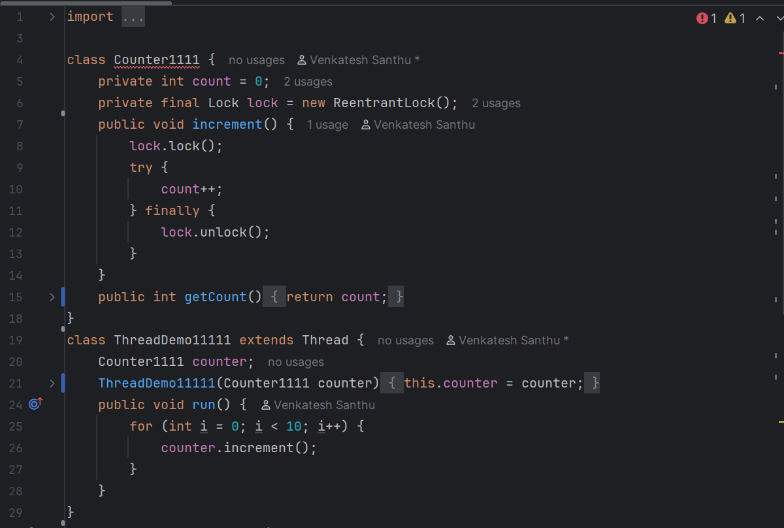

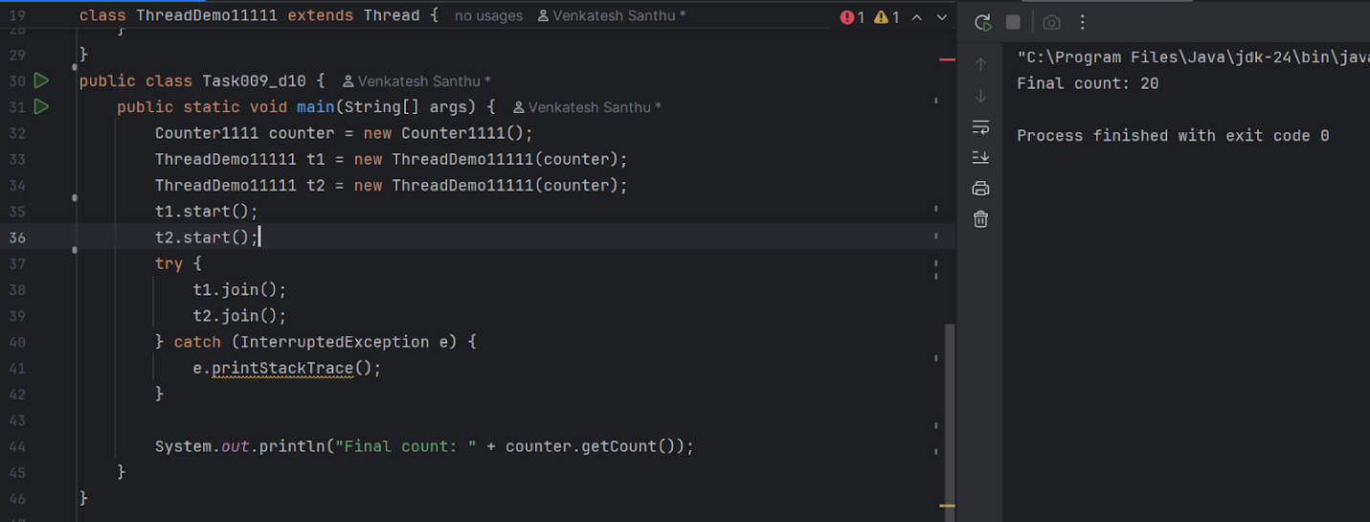

**Task 10**:

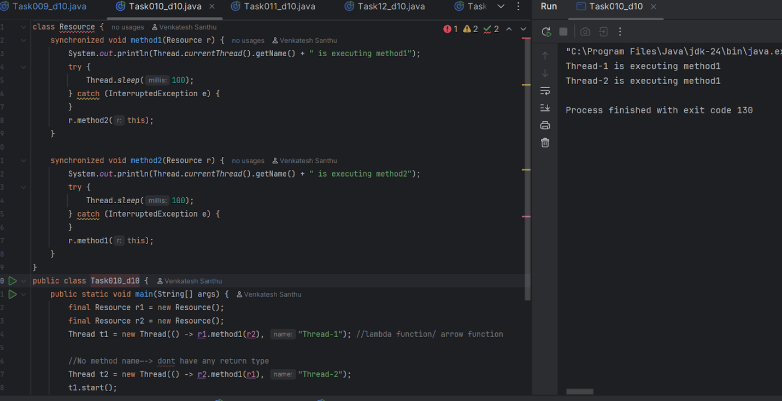

**Task 11**:

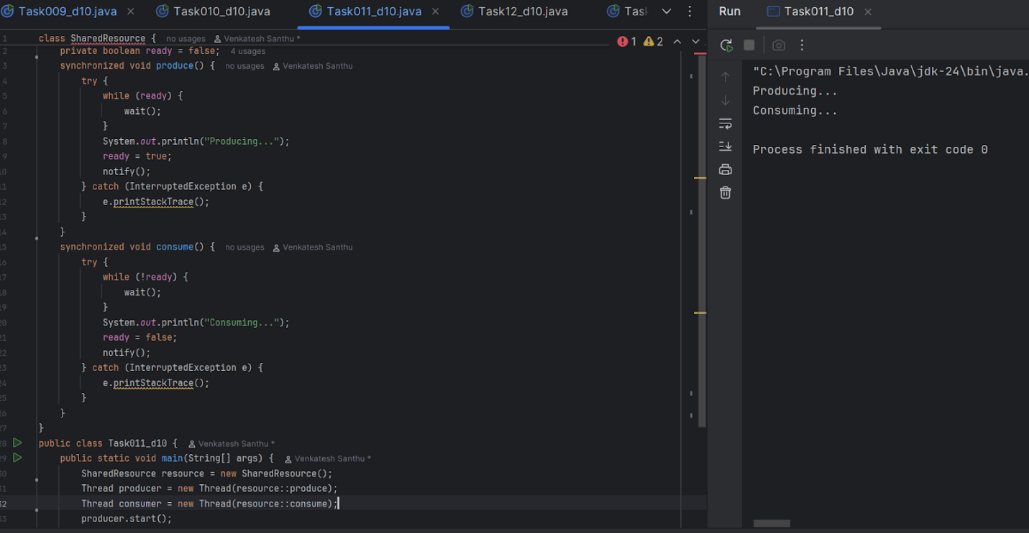

**Task 12**:

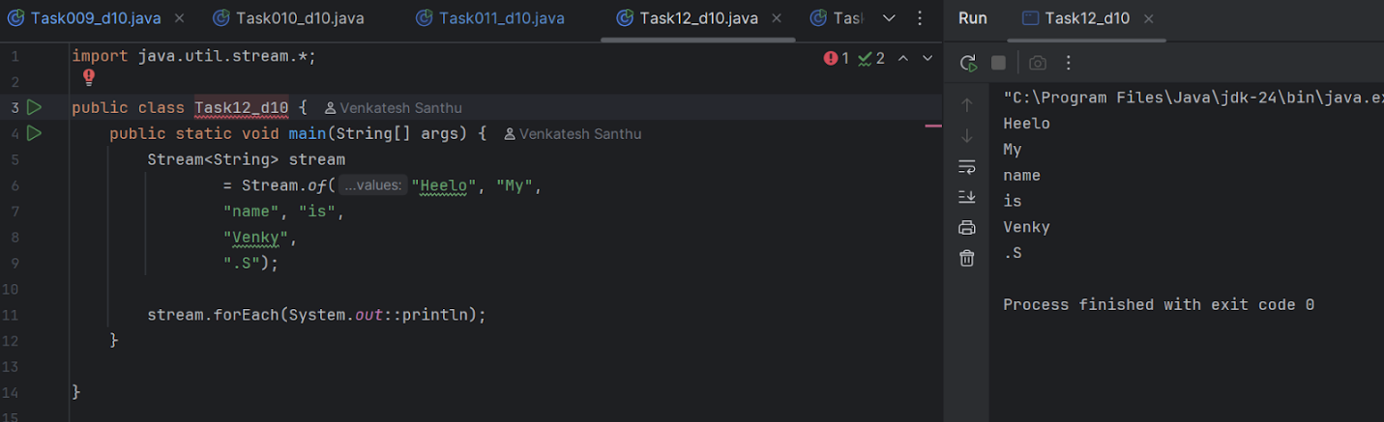

**Task 13**:

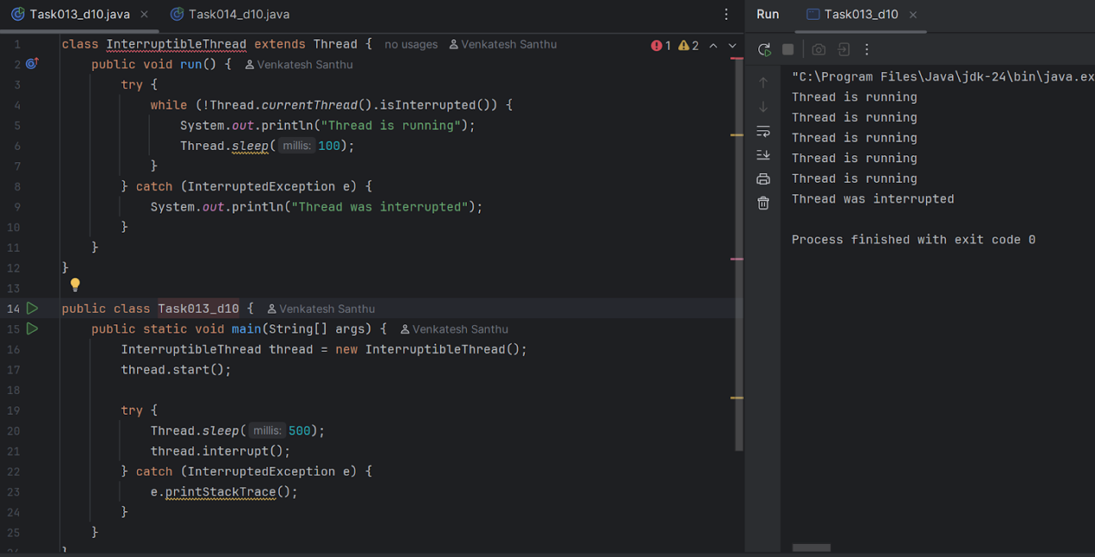

**Task 14**:

